# SnailBlock graphical programming software learning manual

1. SnailBlock software download link:

Open the folder as shown below, and find the software: SnailBlock-Desktop_v1.0.0_win_x64

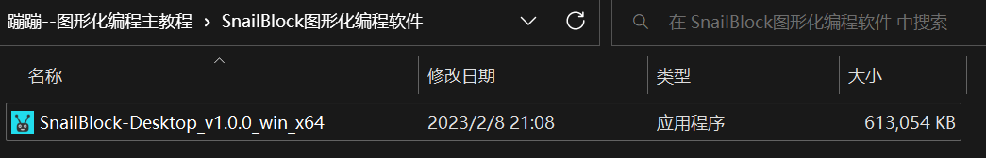

1. Install SnailBlock
2. Double click to install the software



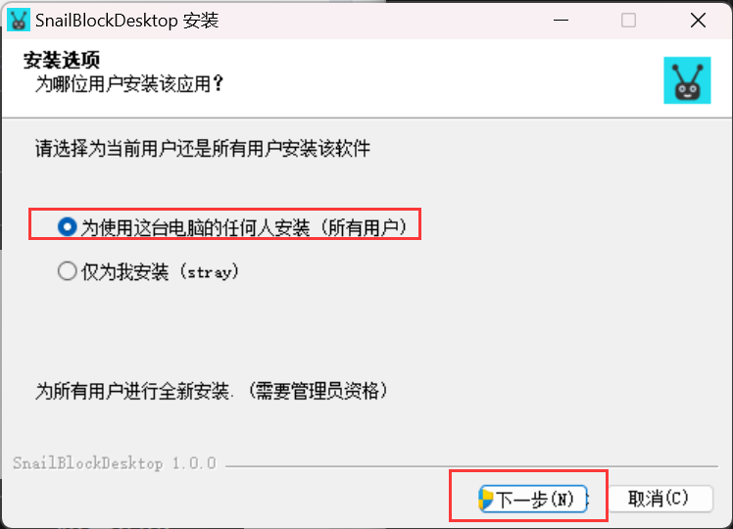

Select “Next” in the pop-up window.

（2）Change the route and click to install.

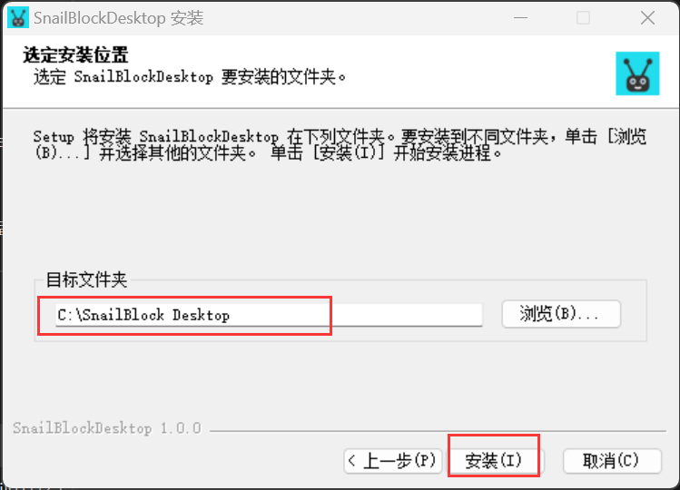

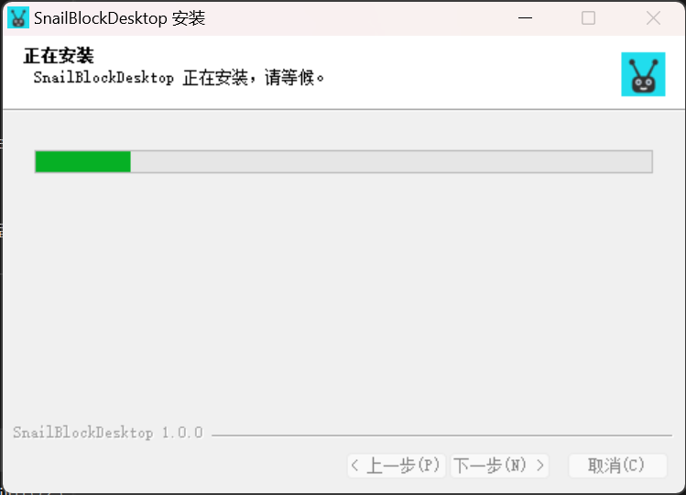

（3）Finish.

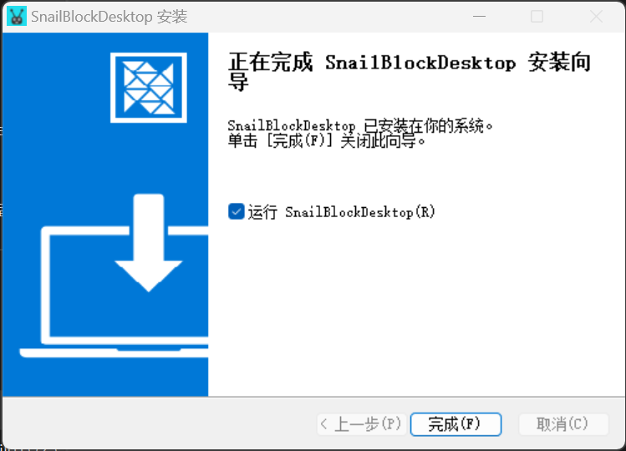

（4）Open the interface of the software.

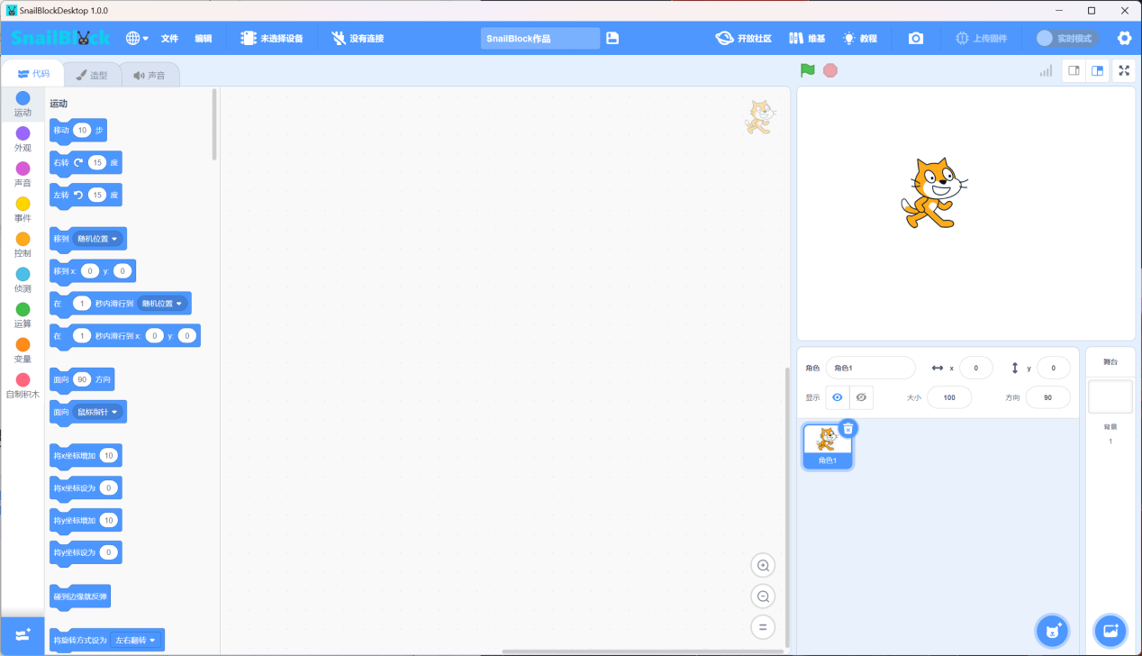

1. Install the driver.

（1）Click the gear at the top right corner of the software interface, and then click “Install driver”.

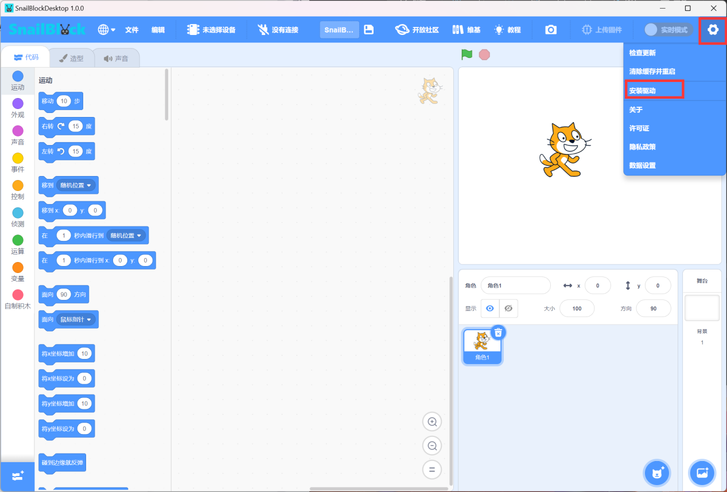

（2）When the pop-up windows appear, select “Allow”.

（3）Test whether the driver is installed successfully.

Firstly, connect the Arduino UNO main board and the computer with the data cable.

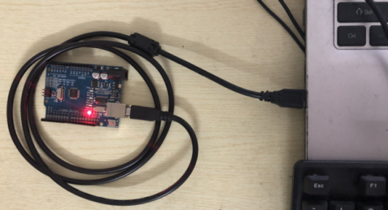

Then select the device in the software, as shown below.

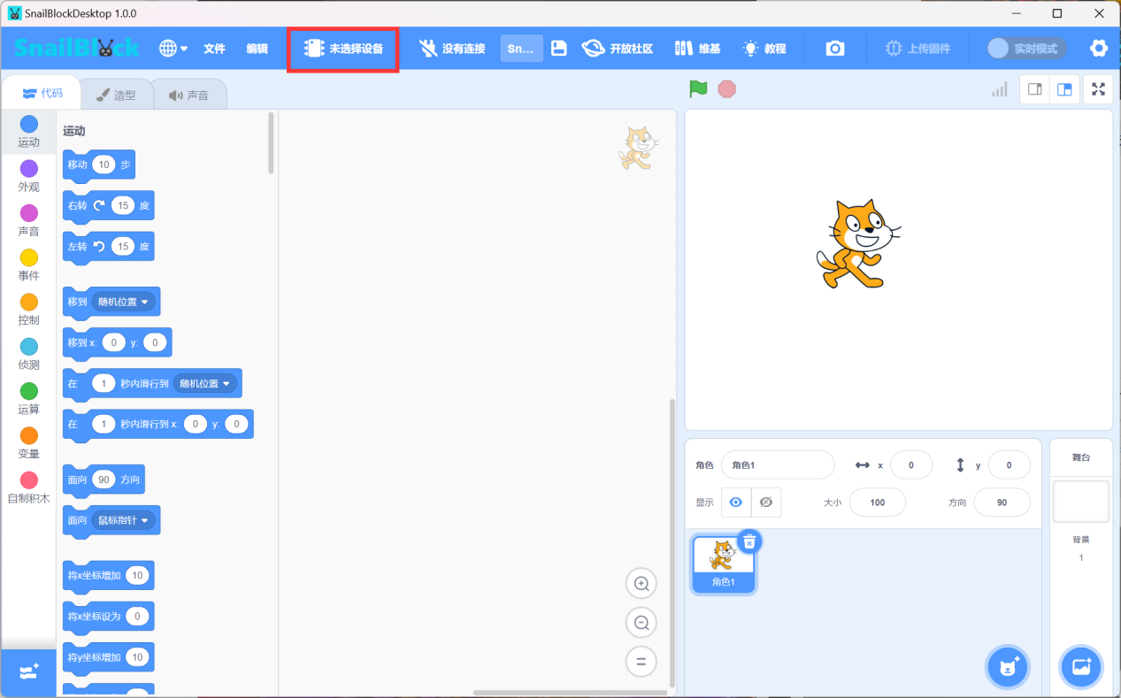

Select Arduino UNO

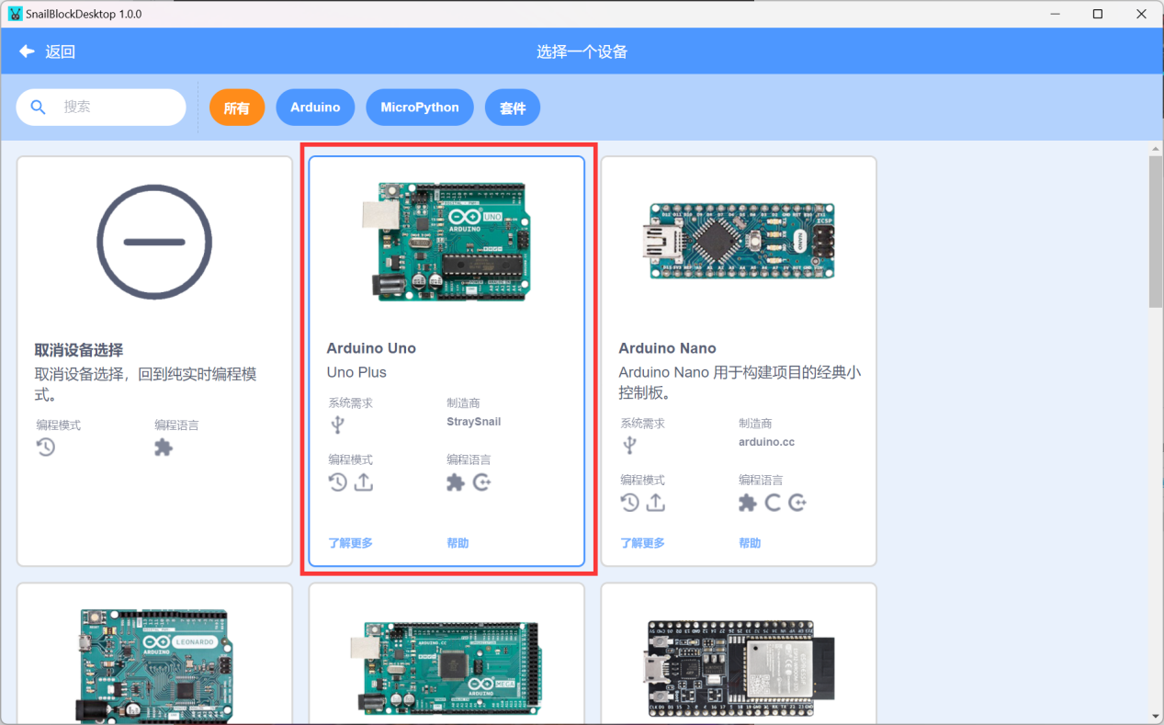

If the device can be found in the pop-up window, it means that the driver has been successfully installed.

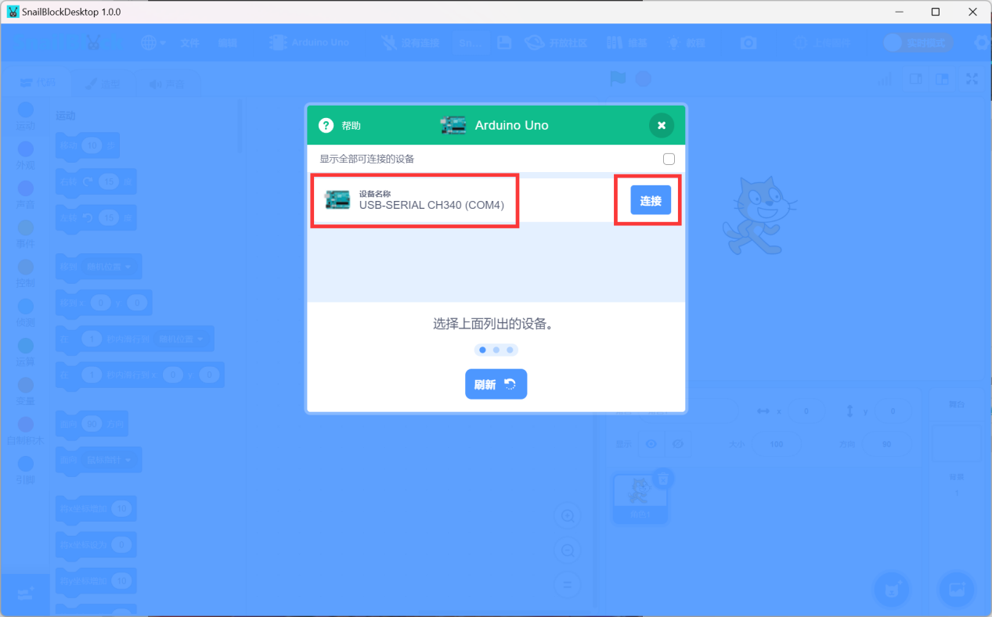

Then click the “Connect” button to connect, and the connection is successful, as shown below.

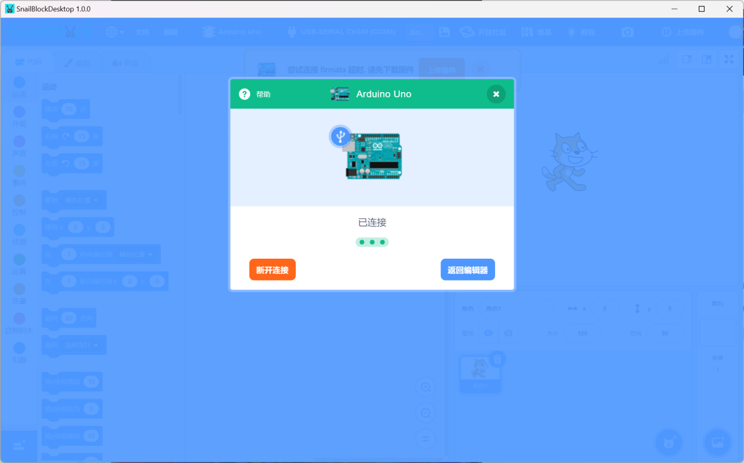

Click “X” to close the window.

## SnailBlock interface introduction

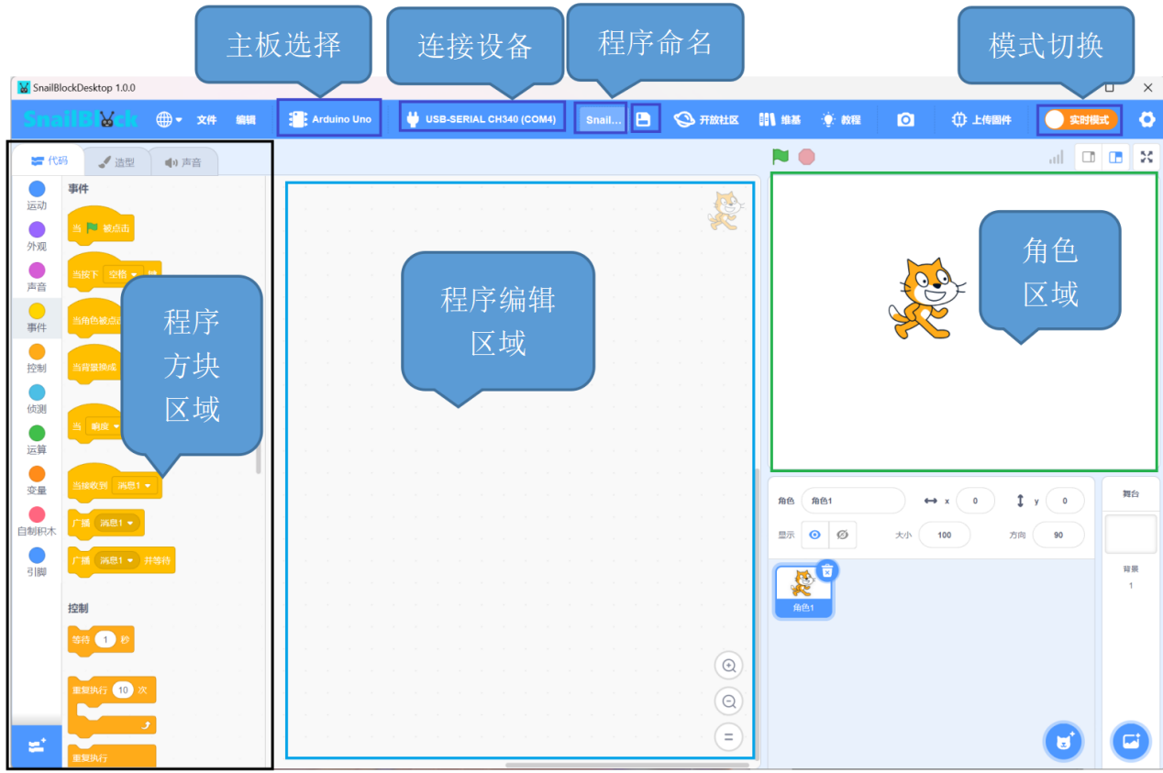

Click “Mode switch” to switch to upload mode.

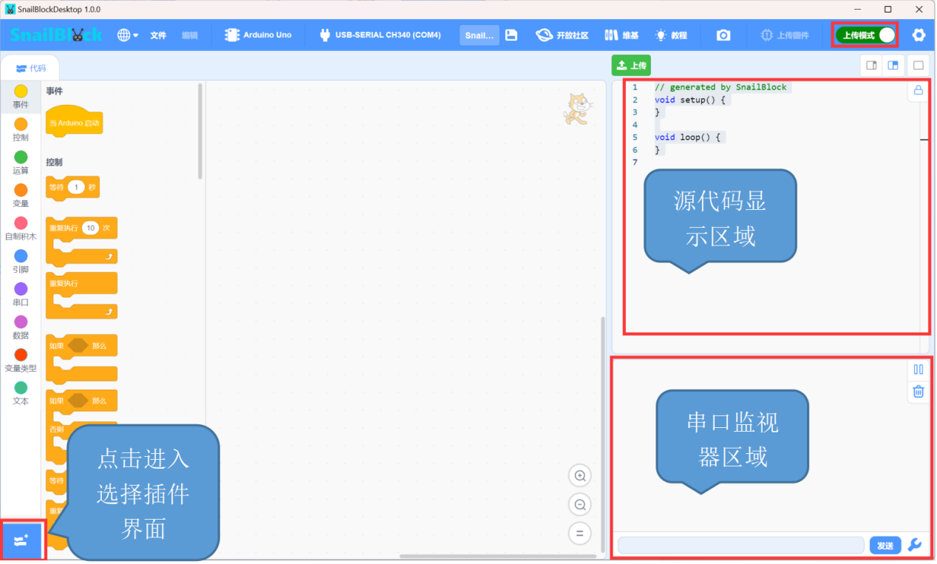

Switch language.

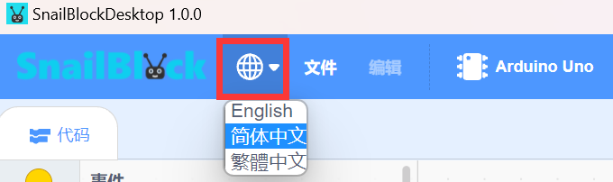

Save files and upload files from your computer.

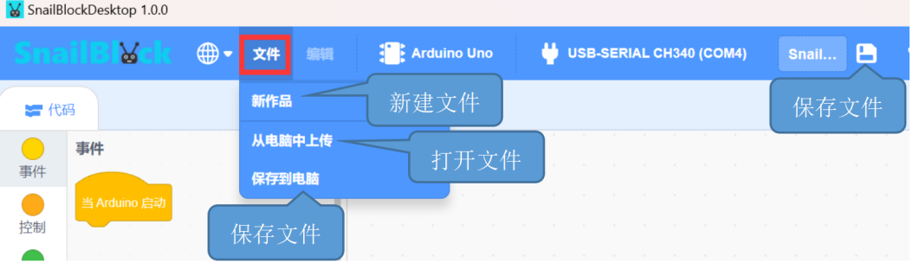

## Write the first program

In the first lesson of programming, control the LED on the Arduino UNO board to flash.

Click the real-time mode tin the top right corner to switch to the upload mode.

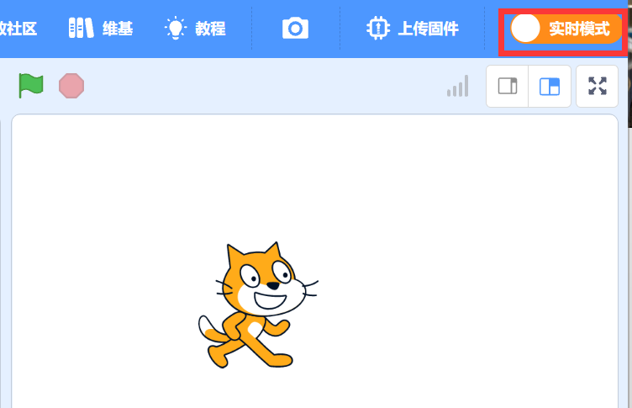

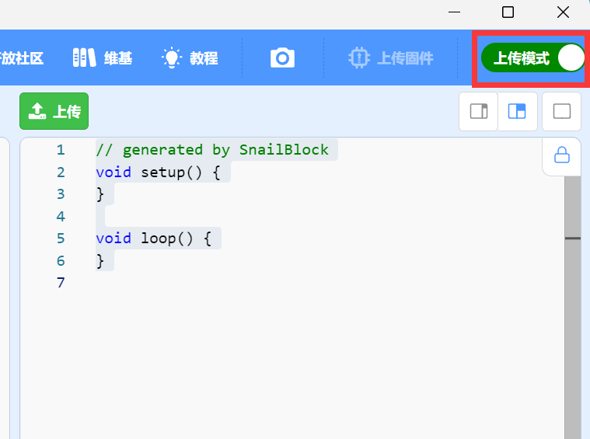

1. Click the event in the code box on the left, and drag “When Arduino startup” under the event to the programming area.

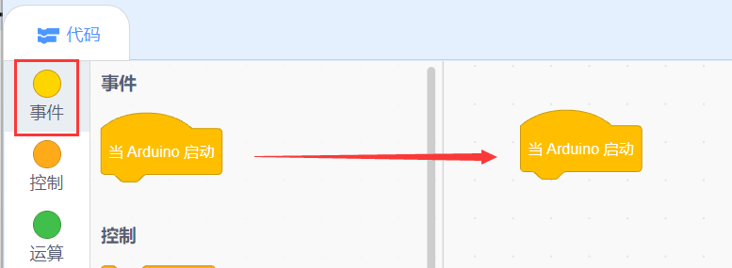

1. Click “Control” to drag out the repeated execution.

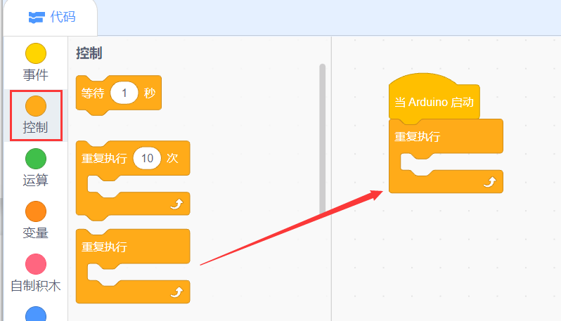

1. Click “Pin”

Drag out the program block for setting pin mode, and modify the pin to 13 and the mode to output.

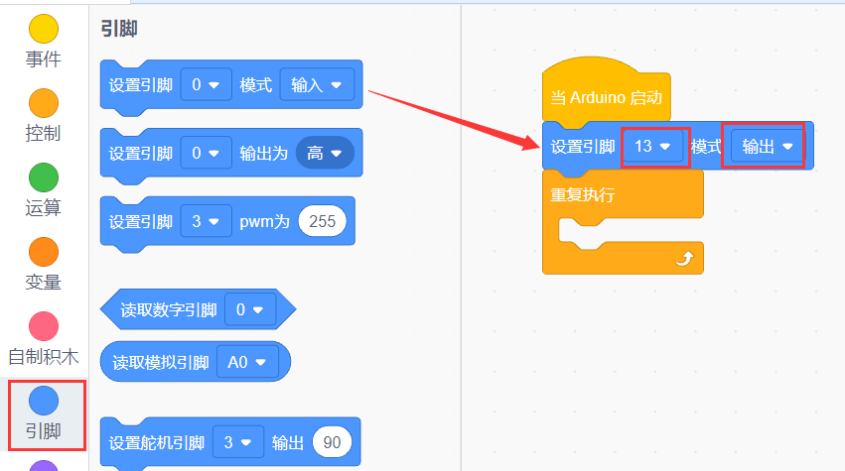

Drag out the program block for setting pin output. Set the pin to 13 and the output is high.

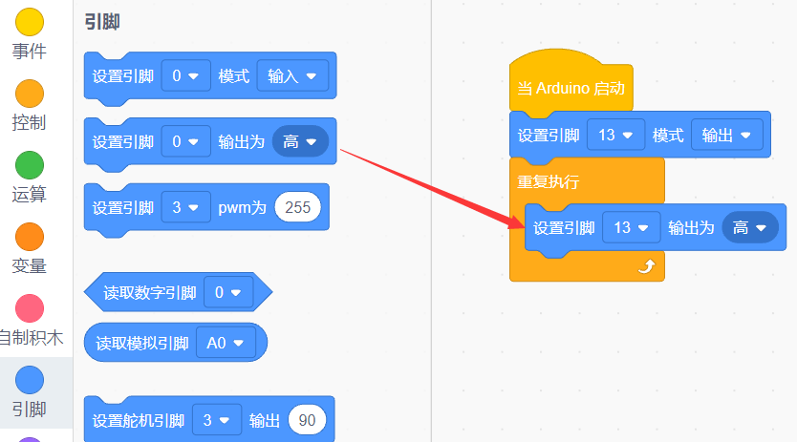

1. Click “Control” and drag out the waiting time program block.

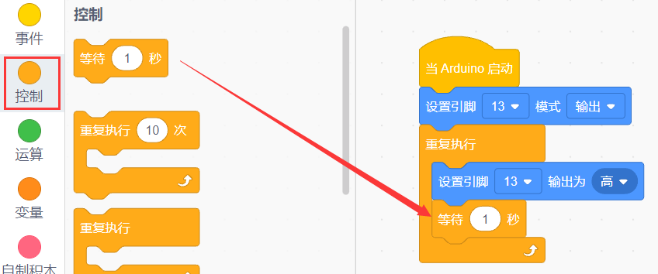

1. Copy the program block

Click the program block of setting pin to output, and right click to copy.

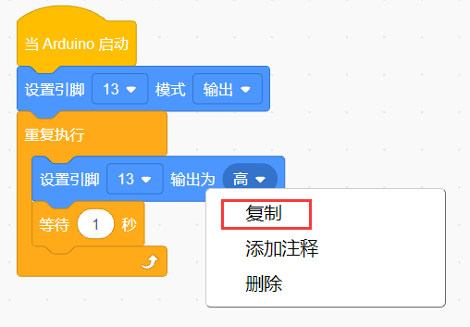

Then you can copy all the program blocks below this program.

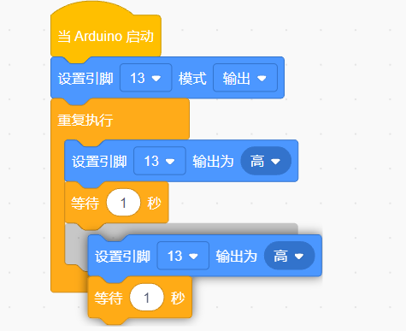

1. Finish the LED flashing program

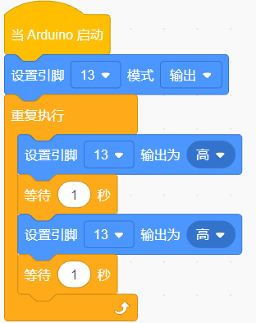

1. Upload the program

Make sure that it is in the upload mode and the main board is selected as Arduino UNO. Click the upload button when the USB connection is successful.

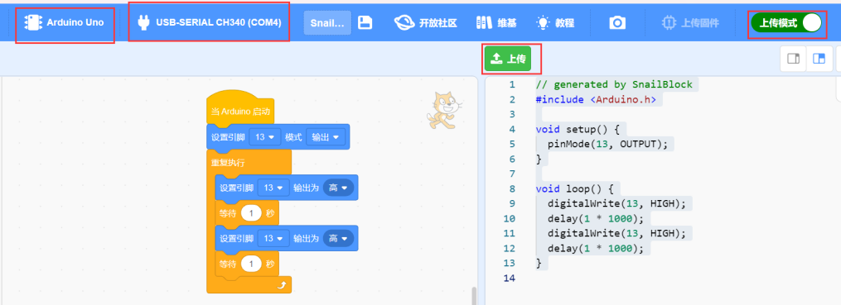

Upload successfully.

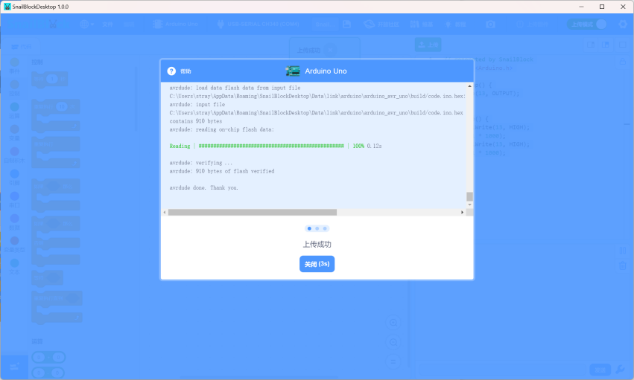

1. Experiment phenomenon

You can see that the LED on the Arduino UNO main board is flashing.

